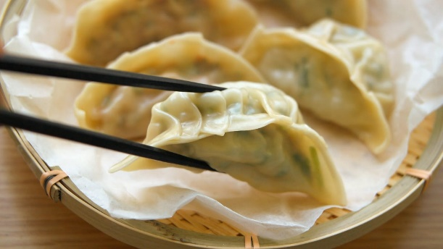  Taste of Korea –Mandu (Dumpling)  Ingredients  Napa cabbage, ground pork, ground beef, chives, glass noodle, bean sprout, egg, onion, salt, soy sauce, rice wine, sesame oil, ginger, black pepper, sugar, dumpling wrapper |  | 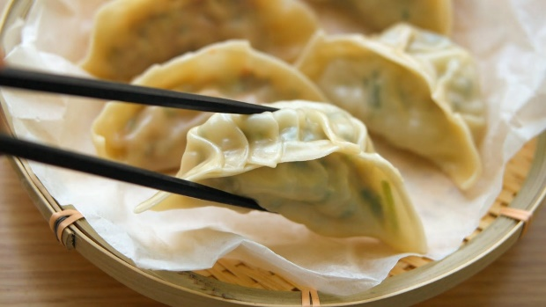  Taste of Korea –Mandu (Dumpling)  Ingredients  Napa cabbage, ground pork, ground beef, chives, glass noodle, bean sprout, egg, onion, salt, soy sauce, rice wine, sesame oil, ginger, black pepper, sugar, dumpling wrapper
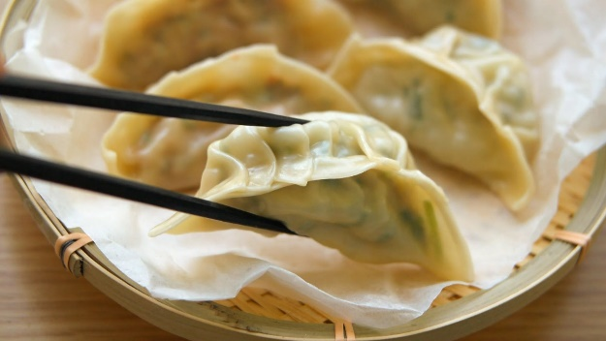  Taste of Korea –Mandu (Dumpling)  Ingredients  Napa cabbage, ground pork, ground beef, chives, glass noodle, bean sprout, egg, onion, salt, soy sauce, rice wine, sesame oil, ginger, black pepper, sugar, dumpling wrapper |  | Taste of Korea –Mandu (Dumpling)  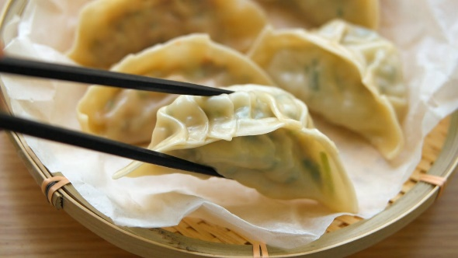  Ingredients  Napa cabbage, ground pork, ground beef, chives, glass noodle, bean sprout, egg, onion, salt, soy sauce, rice wine, sesame oil, ginger, black pepper, sugar, dumpling wrapper
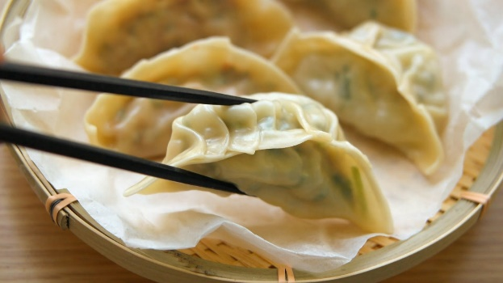  Taste of Korea –Mandu (Dumpling)  Ingredients  Napa cabbage, ground pork, ground beef, chives, glass noodle, bean sprout, egg, onion, salt, soy sauce, rice wine, sesame oil, ginger, black pepper, sugar, dumpling wrapper |  | Taste of Korea –Mandu (Dumpling)  Ingredients  Napa cabbage, ground pork, ground beef, chives, glass noodle, bean sprout, egg, onion, salt, soy sauce, rice wine, sesame oil, ginger, black pepper, sugar, dumpling wrapper

